Homework 8

Jiaqi Li

(a)

Yijt = μ + αi + βj(i) + ϵijt, ϵijt ∼ N(0, σ­2) with iid.

i=Acmel nd, WHSupply, GenWidge j=1, 2, 3, 4 t=1, 2, 3, 4

(b)

The boxes of widgets is a nested factor.

The boxes of widgets are nested within suppliers because each box can only be purchase from one supplier.

(c)

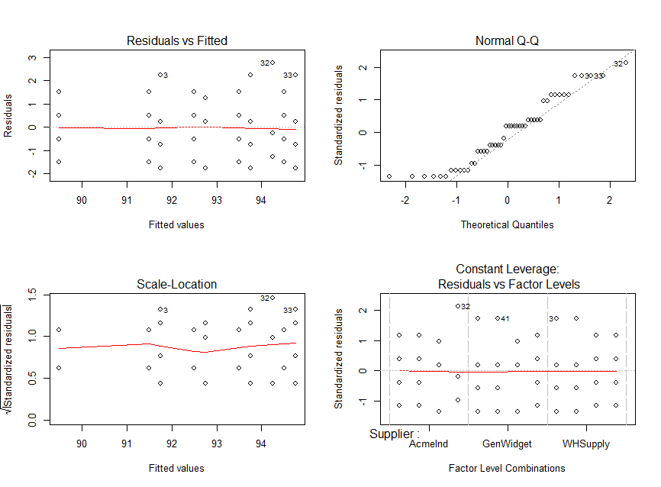

By observing the graphs, we can see that constant variance is satisfied from the first scatter plot and normality is satisfied from the Q-Q plot. However, in the Q-Q plot, points are not fitting the line very well at the left tail. Thus, we try some transformations.

By trying transformation (log, sqrt, inverse), none of these transformations can improve the normality of the residuals. Thus, we will use the original model for further study.

(d)

This part is on the written page.

(e)

> anova(model1)

Analysis of Variance Table

Response: WidgetSize

Df Sum Sq Mean Sq F value Pr(>F)

Supplier 2 6.792 3.3958 1.5234 0.2316974

Supplier:Batch 9 93.437 10.3819 4.6573 0.0003957 ***

Residuals 36 80.250 2.2292

---

Signif. codes: 0 ‘***’ 0.001 ‘**’ 0.01 ‘*’ 0.05 ‘.’ 0.1 ‘ ’ 1

**For Supplier:**

H0: Supplier has no significant impact on mean WidgetSize.

Test-statistic = F2,36 = 1.5234

p-value=0.2316974 > α = 0.05

Since the p-value of Supplier is larger than α = 0.05, we fail to reject hull hypothesis and conclude that Supplier has no significant impact on mean WidgetSize.

**For Combination of Supplier and Batch:**

H0: Supplier has no significant impact on mean WidgetSize.

Test-statistic = F2,36 = 1.5234

p-value=0.0003957 < α = 0.05

Since the p-value of Supplier is smaller than α = 0.05, we reject hull hypothesis and conclude that combination of Supplier and Batch has significant impact on mean WidgetSize.

> cld(lsmBS)

Batch Supplier lsmean SE df lower.CL upper.CL .group

2 AcmeInd 89.50 0.7465197 36 87.98599 91.01401 1

3 WHSupply 91.50 0.7465197 36 89.98599 93.01401 12

2 GenWidget 91.75 0.7465197 36 90.23599 93.26401 12

1 WHSupply 91.75 0.7465197 36 90.23599 93.26401 12

1 AcmeInd 92.50 0.7465197 36 90.98599 94.01401 12

3 AcmeInd 92.75 0.7465197 36 91.23599 94.26401 12

3 GenWidget 92.75 0.7465197 36 91.23599 94.26401 12

4 GenWidget 93.50 0.7465197 36 91.98599 95.01401 2

1 GenWidget 93.75 0.7465197 36 92.23599 95.26401 2

4 AcmeInd 94.25 0.7465197 36 92.73599 95.76401 2

4 WHSupply 94.50 0.7465197 36 92.98599 96.01401 2

2 WHSupply 94.75 0.7465197 36 93.23599 96.26401 2

Confidence level used: 0.95

P value adjustment: tukey method for comparing a family of 12 estimates

significance level used: alpha = 0.05

We can observe that:

* Widget of Batch 2, Supplier AcmeInd has less impact on mean WidgetSize than Widget of Batch 4, Supplier GenWidget and Widget of Batch 1, Supplier GenWidget and Widget of Batch 4, Supplier AcmeInd and Widget of Batch 4, Supplier WHSupplier and Widget of Batch 4, Supplier WHSupplier.
* No other comparisons are significantly different than zero.